Jackson, Terrence. CMIS 141 7383. 10.30.2022.

|  | Input | Expected | Actual | Pass? |
| --- | --- | --- | --- | --- |
| Test Case 1 | custid: 2626  price: 15.99  quantity: 3  description: Headphones  discount: .15 | ORDER DATA  Customer ID: 2626  Unit Price: 15.99  Quantity: 3  Product Description: Headphones  Discount: 15.0%  Order Total BEFORE discount: 47.97  Order Total AFTER discount: 40.77 | ORDER DATA  Customer ID: 2626  Unit Price: 15.99  Quantity: 3  Product Description: Headphones  Discount: 15.0%  Order Total BEFORE discount: 47.97  Order Total AFTER discount: 40.77 | yes |
| Test Case 2 | custid: 5978  price: 250.65  quantity: 17 description: Lawn Chair  discount: .37 | ORDER DATA  Customer ID: 5978  Unit Price: 250.65  Quantity: 17  Product Description: Lawn Chair  Discount: 37.0%  Order Total BEFORE discount: 4261.05  Order Total AFTER discount: 2684.46 | ORDER DATA  Customer ID: 5978  Unit Price: 250.65  Quantity: 17  Product Description: Lawn Chair  Discount: 37.0%  Order Total BEFORE discount: 4261.05  Order Total AFTER discount: 2684.46 | yes |
| Test Case 3 | custid: 65423165  price: 5.00  quantity: 75000  description: Car discount: .075 | ORDER DATA  Customer ID: 65423165  Unit Price: 75000.00  Quantity: 2  Product Description: Car  Discount: 7.5%  Order Total BEFORE discount: 150000.00  Order Total AFTER discount: 138750.00 | ORDER DATA  Customer ID: 65423165  Unit Price: 75000.00  Quantity: 2  Product Description: Car  Discount: 7.5%  Order Total BEFORE discount: 150000.00  Order Total AFTER discount: 138750.00 | yes |

Test Case 1:

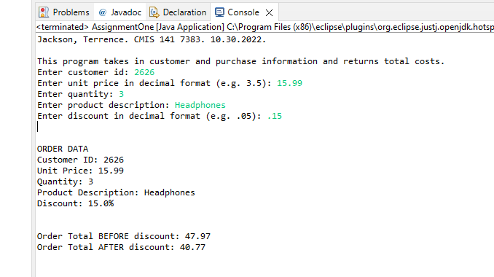

Test Case 2:

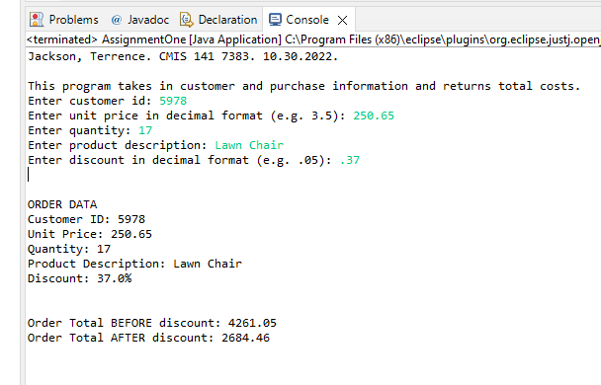

Test Case 3:

